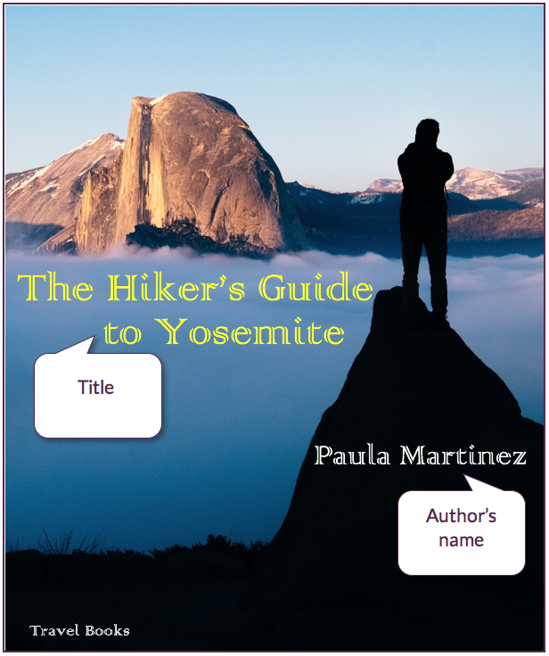

**Source is fictional**

Travel Books

Paula Martinez